**ToDoTask**

**Abstract**

ToDoTask is an Java swing application that allows to manage a list of tasks to do. It performs login and adding, updating, deleting and toggling state of each task. It has minimalistic design and basic functionality.

This application is developed using Netbeans IDE and java. It also used mySql for database connection.

**Features**

* Create a user account
* Add Todo list
* Add End Date to complete
* Select to Update List and Date
* View Finished and Unfinished Task
* Select to Remove Completed Task

**Database Tables**

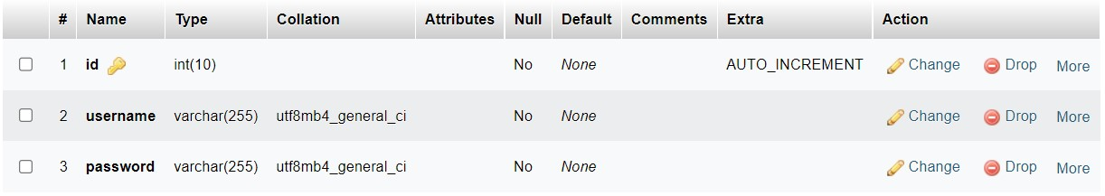

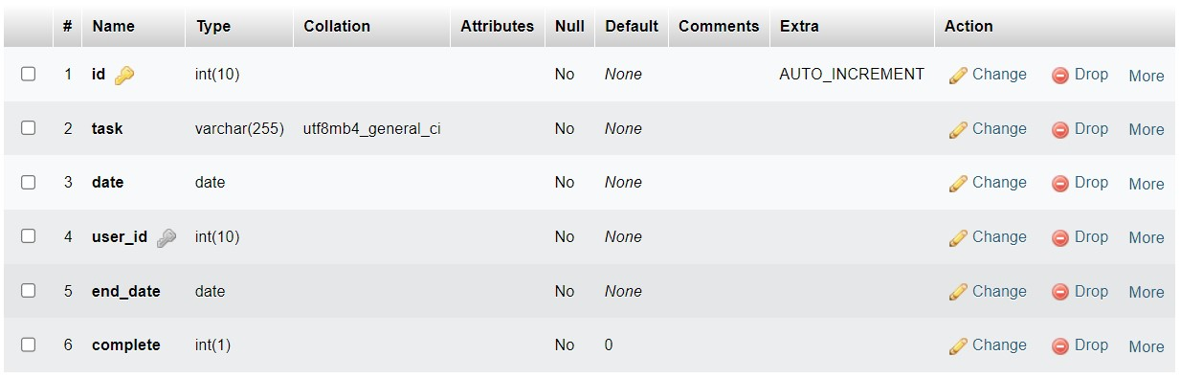

**Screenshots**

Register Page :

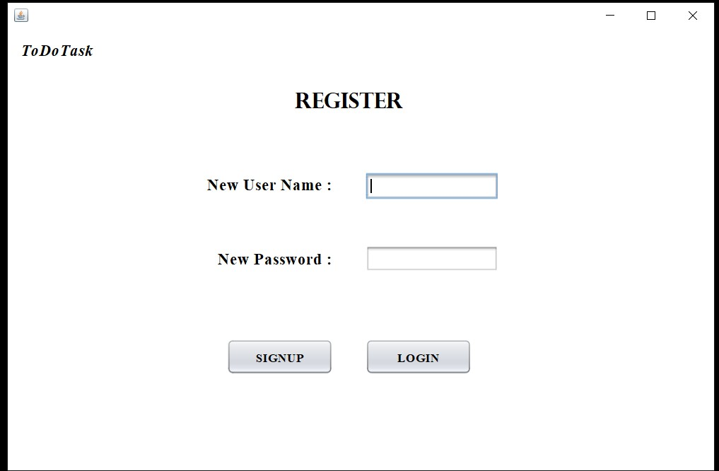

Main Page :

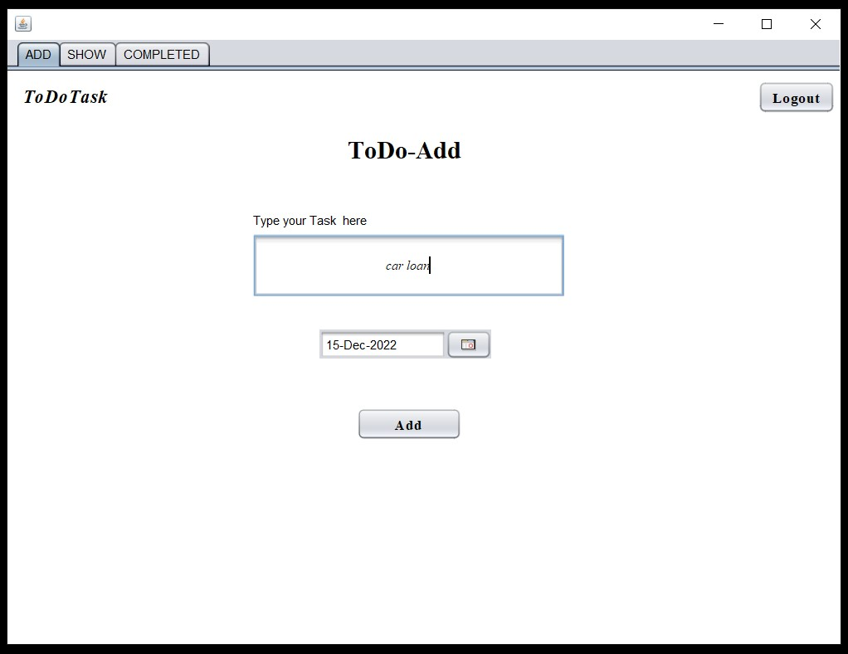

View page :

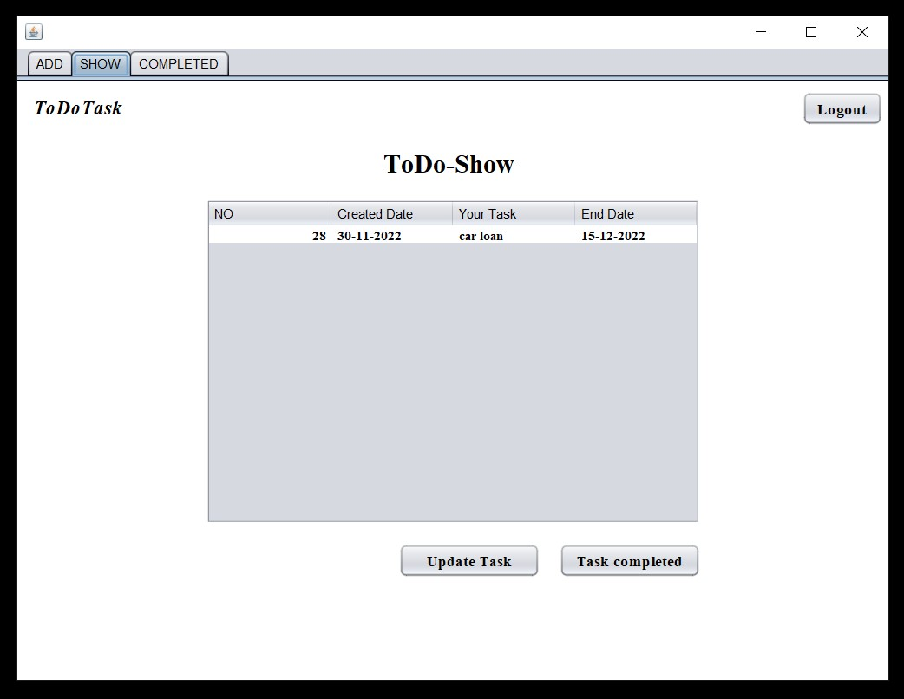

Update page :

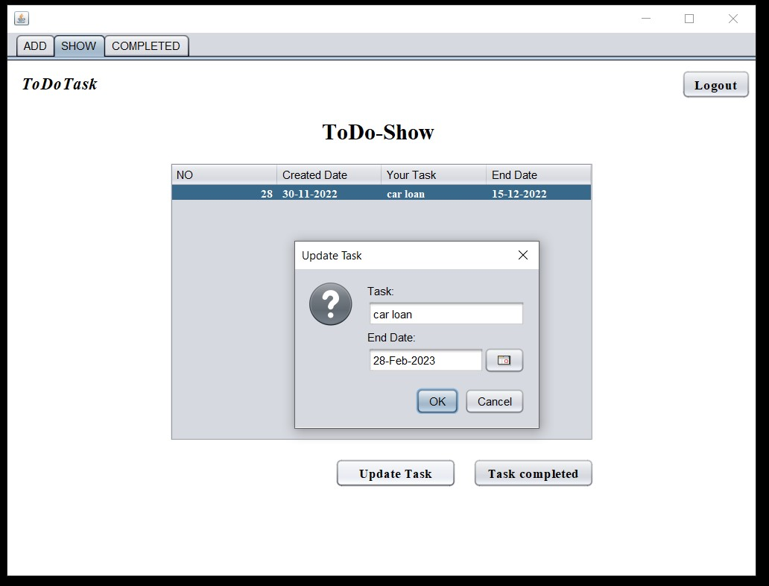

Completed page :

